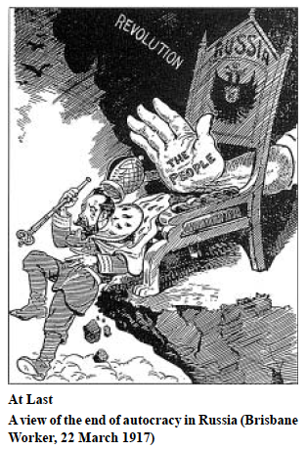

a. Identify two symbols of the Tsar’s autocratic power shown in the representation.
2 Marks

b. Identify two features (not listed in response a. above) shown in the representation, which symbolise the revolutionary situation in February 1917.
2 Marks

c. By referring to parts of the cartoon, and using your own knowledge, explain how the events of February 1917 resulted in the abdication of Tsar Nicholas.
6 Marks

The strikes in Petrograd as a result of involvement in WWI would force the Tsar to abdicate by February 1917. Firstly, involvement in WWI would further weaken the Tsar’s leadership. Nicholas decided to leave Petrograd to take command of the armed forces in Mogilev (June 1915). As a result, he left Alexandra in charge; this act would alienate the Tsar and his family from the majority of Russians, as they did not trust Alexandra. Her lack of leadership and German decent brewed hatred of the ruling family. By February many would be calling for their abdication. Secondly, the social and economic impacts would force many workers in Russia to protest and riot. Food riots broke out in Petrograd as a result of Russia’s inability to transport food supplies to where they were required. Furthermore, unemployment and inflation made living untenable, as the majority of workers could no longer afford basic goods. What begun as a small protest at the Putilov Steel Works (18 February 1917) would culminate in open anarchy as the people demanded an end to their dire situation. As seen in the cartoon above, the hand of the mob pushed the Tsar off his already unstable position as Tsar and over the cliff, forcing his abdication. The Tsar’s inability to respond to the key crises of February 1917 lead to his downfall.

d. Evaluate to what extent this cartoon provides an accurate representation of the reasons for the success of the Revolution of February 1917.
In your response refer to different views of the Revolution of February 1917.
6 Marks

Topic Sentence(s):
The document “At Last” presents a reliable and accurate representation of why Tsar Nicholas abdicated the throne in February 1917. It depicts Tsar Nicholas in military garb pushed off his throne, already sitting on a precarious position at the end of a cliff. Historian Sheila Fitzpatrick would support the contention made by the author, placing Tsar Nicholas on the edge of a cliff. His position as ruler of Russia was already in a difficult position due to his inability to reform. Fitzpatrick states “Autocracy’s situation was precarious on the eve of the First World War … it is hard to imagine that it could have survived long even without the War.” However, historian Richard Pipes contends that WWI exacerbated the Tsar’s position in Russia. He writes that “[it] proved fatal under the pressure generated by WWI.” This is depicted in the document with the Tsar dressed in military garb; indicating that his involvement in WWI was a key cause of the February Revolution. On the other hand, Soviet historians such as Trotsky argue that the Bolsheviks brought about the abdication of the Tsar. Trotsky argues that “the conscious and tempered workers educated for the most part by the party of Lenin” led the revolution. This can be seen by the hand pushing the Tsar off his throne, representing the people, and the cloud of the revolution behind the hand, indicating the role of the Bolsheviks in educating the proletariat. Therefore this document is a reliable source, as many historians can use aspects of the cartoon to justify arguments as to the causes of the Tsar’s abdication.

Partially Reliable documents

This document presents a somewhat reliable view …… , as it does show …., however it does not depict …….

Why is it reliable – what’s in the document, historian view and historian quote.

However, the document fails to analyse/depict/show/demonstrate ….

Summarise – this document is ….

The extract represents a reliable view as it conveys the tension that lead to the Tsar being forced to abdicate on the 2nd March 1917, and the establishment of the Provisional Government. It seems to come from a Marxist perspective, as it accented the role of ‘the people’ in forcing the Tsar out of power, and as the throne is positioned on the edge of the cliff, conveys the view that revolution was inevitable in accordance with Marxist ideology and the idea of ‘revolution from below’. However Marxist historians, like Trudell, would go further to state that the February Revolution whilst achieving the necessity of getting rid of the Tsar, created a temporary government that did not express the wishes of the proletariat the way the Bolsheviks would when they legitimately and popularly gained power on 25th–26th October 1917. However a Liberal historian like Pipes would contend that this graphic was incorrect and that revolution was not a necessary or inevitable event, performed by ‘the people’ but rather an exploitation of the circumstance of war ‘from above’. Liberals would see the government put in place in February as democratic and popularly supported, making the ‘classic coup d’etat’ of October illegitimate.

