Unit 4: The Chinese Revolution
Area of Study 1: Causes of the Revolution - Timeline
1912 (The Foundation of the Chinese Republic) to 1949 (Communist Revolution).

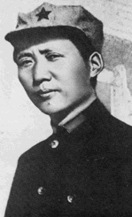
Photo: A young Mao Zedong in 1927

Week | Topics | Homework task/SAC | Reading
Term 2 Week 8 | • Introduction outline assessment tasks, introduction to China  • China- Geography and Ethic Groups  • Philosophy and Religion  • Class system of China:  • Problems with peasants  • Role of women | Outcome task: H.W Task 1 | p.8-10  p.10-11
9 | Year 12 Trial Exams | Trial Exam
10 | • The role of foreign Influence  • Problems with military  • The dying days of the Qing Dynasty and the rise of Yuan Shikai  • Sun Yat-sen and his Tongmenghui (Revolutionary Alliance)  and the “Double Ten Revolution” or “Wuhan Uprising” of 1911 |  | p. 15-17  p.17-19  p.19-25  p.26-34
11 | • Yuan Shikai’s early conflicts with the Republic- 1911-13  • The New Culture Movement (1914-1918)  • May Fourth Movement  • The Foundation of the Chinese Communist Party  • Sun’s attempt to restore the Republic 1917-1921 |  | p.80-85  p.96-105
Term 3  Week 1 | • Leader Profile: Chiang Kai-Shek (1887-1975)  • Chiang Kai-Shek’s Northern Expedition (1926-1928)  • The Shanghai Massacre (April 12th 1927)  • Leadership profile- Mao Zedong (1893-1976)  • Threats faced by the CCP 1927-1931  • The Jiangxi Soviet (1931-1935) | Holiday H.W | p. 107-114  p.115-132
2 | • The Nationalist Decade (1927-1937)  • The Long March (1934)  • The Second United Front | H.W Task 3 | p.133-148
3 | • The Yan’an Soviet  • The Second Sino-Japanese War- Its role in contributing to a revolutionary situation.  • The Chinese Civil War- (May 1946- October 1949) | Practice SAC Task | p.148-152
4 | Revision | SAC 1: Evaluation of historical interpretations | p.148-152

Area of Study 2: Creating A New Society - Timeline
1949 (Communist Revolution) to 1971 (death of Lin Biao)

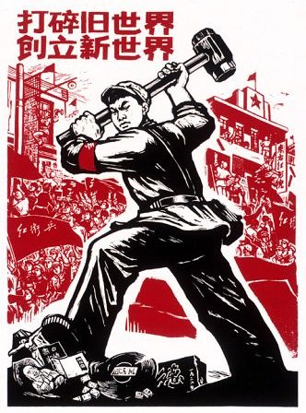
“Destroy the old world; build a new world." (1966)

Week | Topics | Homework task/  Assessment item | Reading
Term 3  Week  5 | • Political Structure in The People’s Republic  • Consolidating Communist Power  • Invasion of Tibet (1950)  • The Korean War (25th June 1950- 27th of July 1953)  • Fanshen: ‘Turning Over’ (28th of June 1950) |  | p.161-172
6 | • Thought Reforms (early 1950’s)  • The Anti Campaigns  • Social Reforms (Early 1950s)  • The First Five Year Plan (1952-1957) | H.W Task 1 | p.173-183
7 | • The Gao Gang affair (1953-54)  • Other economic reforms of the 50’s  • Eight Party Congress and other challenges of 1956  • The Hundred Flowers Campaign (1957) |  | p.183-191
8 | • The Great Leap Forward (1958-1961)  • Early reactions to the Great Leap Forward  • Final consequence of the Great Leap Forward: The Three Bad Years | H.W Task 2 | p.192-207
9 | • The Great Proletarian Cultural Revolution-Part 1- The Causes  • Part 2- Launching the Great Proletarian Cultural Revolution  • Part 3- The Effects  • The Death of Lin Biao | Practice essay questions | p.221-268
10 | Mao’s last years and revision. SAC 2 | SAC 2: Essay

