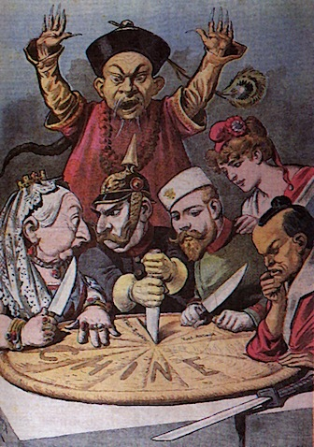
French Political Cartoon
Published in the late 1890s

- Identify 2 nations depicted carving up Imperial China (2 marks)
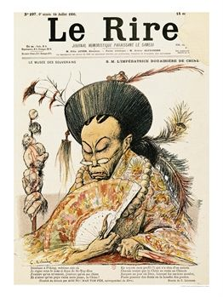
- Identify 2 features which suggest it is taking place during the Qing dynasty (2 marks)
- Using your own knowledge and the cartoon, explain the external factors which created a revolutionary situation in China by 1911.
- Explain to what extent this presents a reliable view of foreign presence in China prior to 1911.

French Publication Le Rire 1905

- Identify 2 features of Qing rule in the image to the left.
- Identify 2 features (not listed in a.) which suggests disapproval with Cixi’s rule
- Using the cartoon and your broader knowledge, explain how Cixi’s rule contributed to the Wuhan Uprising in 1911.
- Explain to what extent this cartoon presents a reliable view of the Dowager Empress Cixi in the period 1898-1908. In your response refer to different historians perspectives.

The Sun-Joffe Declaration 1923

Dr Sun is of the opinion that, because of the non-existence of conditions favorable to their successful application in China, it is not possible to carry out either communism or even the Soviet system in China. Mr Joffe agrees entirely with this view; he is further of the opinion that China’s most important and most pressing problems are the completion of national unification and the attainment of full national independence. With regard to these great tasks, Mr Joffe has assured Dr Sun of the Russian people’s warmest sympathy for China, and of willingness to lend support.

- State 2 of China’s ‘most pressing problems?’
- What two systems of government does Sun believe are not applicable in China at this time?
- Using the document above and your own knowledge, explain the reasons why China was not unified at this time.
- To what extent does this document provide a reliable view for understanding the Soviet influence in China up to 1923?

Sun Yat-Sen on the Republic and Soviet Russia, 1923

The Republic is my child and it is in danger of drowning. I am trying to keep it afloat and we are being swept down the river. I call for help from England and America. They stand on the bank and jeer at me. There comes a Russian straw. Drowning I clutch at it. England and America, on the bank, shout at me, on no account to clutch the Russian straw. But they do not help me. They jeer themselves at the same time tell me not to clutch that Russian straw. I know it is a straw, but it is better than nothing.

- Why was the republic in danger of drowning?
- What metaphor is the Russian straw?
- For your knowledge and the document above, why did the West fear Russian involvement in China?
- To what extent does this document provide a reliable view of the influence of Soviet revolutionary ideas and organizations in China up to 1923.

Yang Chengwu, account of the Luding Bridge Battle

The attack begun at four in the afternoon. The regimental commander and I directed it from the west end of the bridge. The buglers of the regiment gathered together to sound the chare, and we opened up with every weapon we had. The blare of the bugles, the firing and the shouts of the men reverberated through the valley. The 22 heroes, led by Commander Liao, crept across on the swaying bridge chains in the teeth of intense enemy fire. Each man carried a tommy-gun or a pistol, a broadsword and 12 hand grenades. Behind them came the men of the Third Company, each carrying a plank in addition to full battle gear. They fought and laid planks at the same time.

Just as the assault party reached the bridgehead on the opposite side, huge flames sprang into the sky outside the town’s west gate. The enemy was trying to throw a fire barrier across our path. The blaze, reddening the sky, licked fiercely across the end of the bridge.

The outcome of the attack hung in the air … With the clarion call of the bugles, our assault party swiftly plunged into the flames. Commander Liao’s cap caught on fire. He threw it away and fought on. The others also dashed through the flames, closely behind Liao … Our gallant men fought until all their bullets and grenades were spent. The Third Company came charging to their rescue. The regimental Commander Wang and I sped across the bridge with our reinforcements and entered the town … The enemy’s dream ended in smoke, for though we followed the same route as Shi Takai [the Taiping general killed by the Qing], history did not repeat itself. Ours was a people’s army led by the Communist Party and Chairman Mao.

- State two tactics the enemy used to stop the approaching Communists.
- Identify 2 armies that have tried to cross the Luding Bridge.
- Using your knowledge and the document above, what was the significance of the Luding Bridge crossing to the revolution in 1949.
- To what extent does this document provide a reliable view of what happened at Luding Bridge. Refer to different historians of the period.
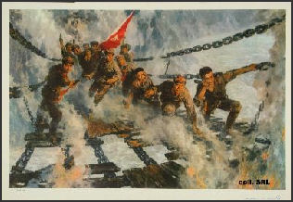

Swiftly taking the Luding Bridge

- State 2 difficulties in corssing the bridge
- Descirbe 2 features of the portayal of the Communist soldiers
- Using your knowledge and the document above, explain the importance of the Luding Bridge crossing during the Long March.
- To what extent does this source present a reliable view of the difficulties faced by the CCP during the Long March. Refer to different historian in your response.

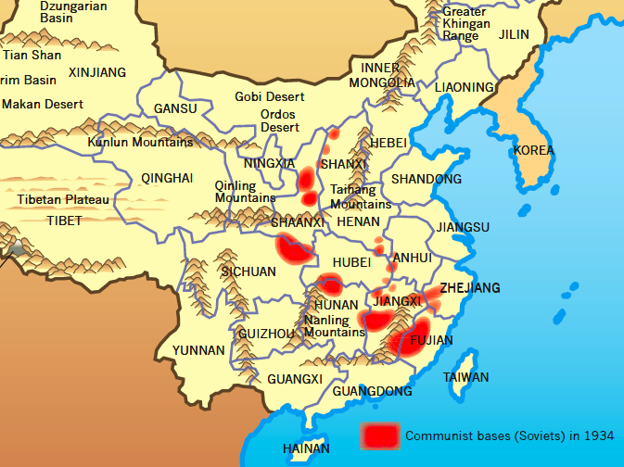
Location of Chinese Soviets, 1934

- Identify 2 geographical features of Chinese Soviets in 1934
- Identify 2 soviets in the depiction to the left
- Using your knowledge and the document above, explain the importance of the location of Soviets in shaping the future directions of the CCP.
- To what extent does this document present a reliable view of the policies taken by the CCP leadership.

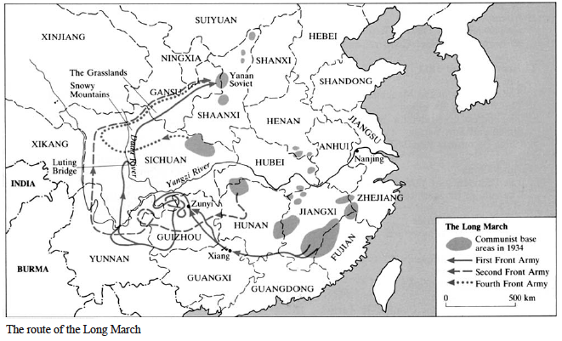
Using the map, state where the ‘Long Marchers” begun and ended their journey.
- What does the map suggest about the nature of the Long March
- Using your knowledge and the document above, explain the significance of Zunyi and Luding Bridge on the Long March.
- Evaluate to what extent this source is useful in determining the significance of the Long March in the development of the Chinese Communist Party. Refer to different views in your response.

