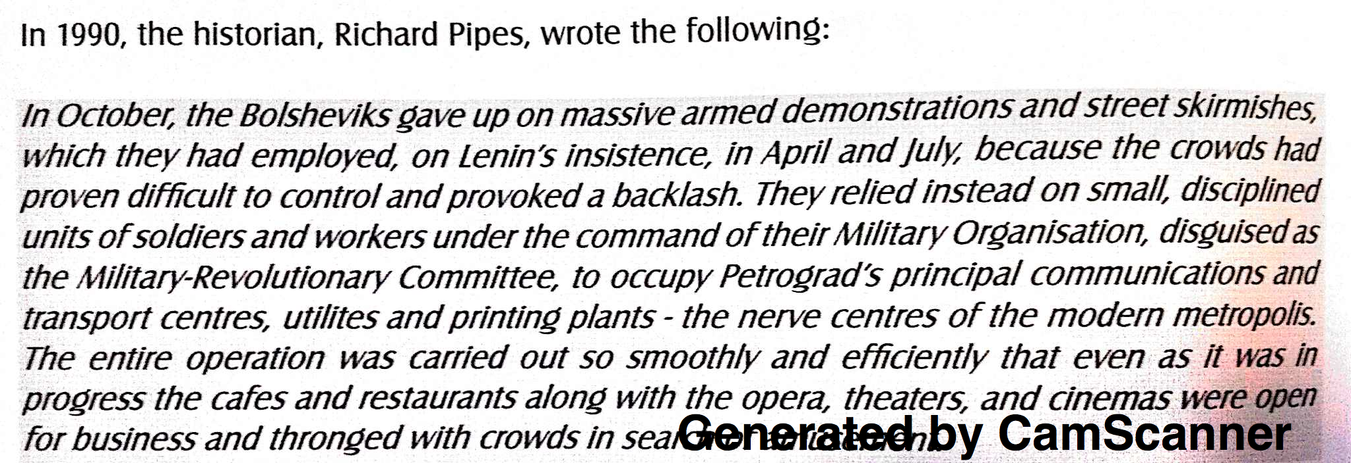
(last sentence: … crowds in search of amusement.)

- Identify 2 reasons why the Bolsheviks had given up on large armed uprisings.

- Identify 2 major groups under command of the Military Organisation.

- Using your knowledge and the document above, explain how the Bolsheviks secured power by October 1917.

- Explain the usefulness of this extract in understanding the role of the Bolshevik Party and their ideology in the October Revolution of 1917.

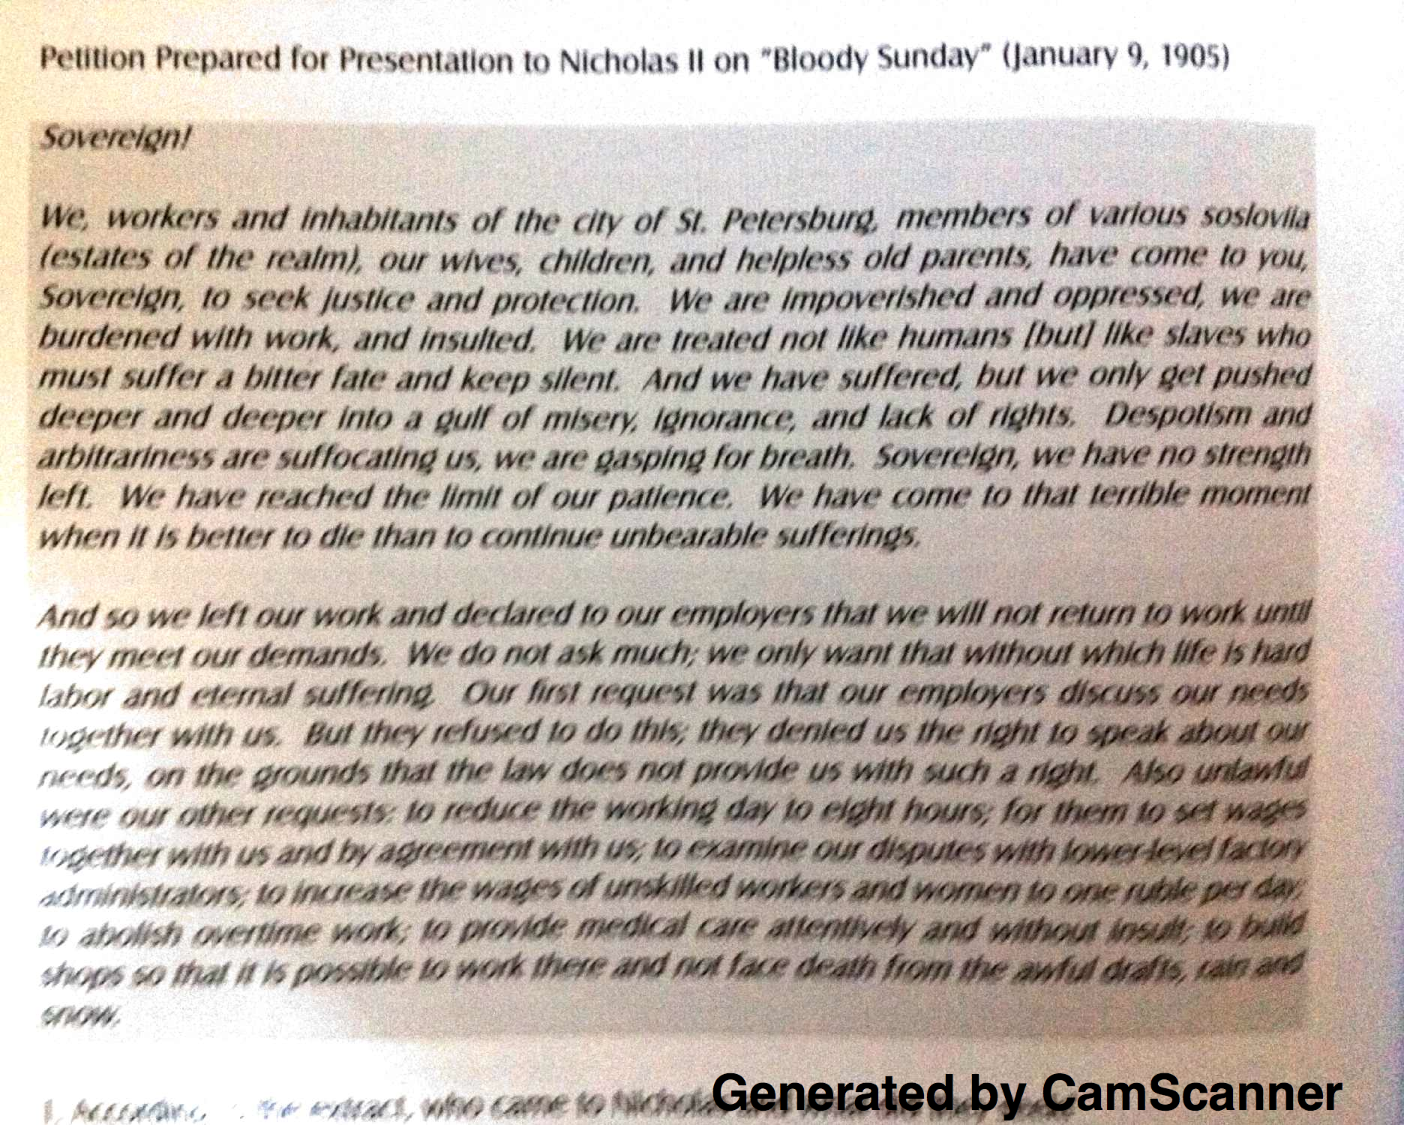
- Identify 2 requests made by the petitioners in the extract above.

- Identify 2 statements made by the petitioners suggesting that the people of Russia were willing to fight for change

- Using your knowledge and the extract above, explain the role of tension and class conflict had on the contribution to a revolutionary situation.

- Explain the usefulness of this extract in understanding the needs of the Russian people and their motivation in presenting their petition to the Tsar in 1905.

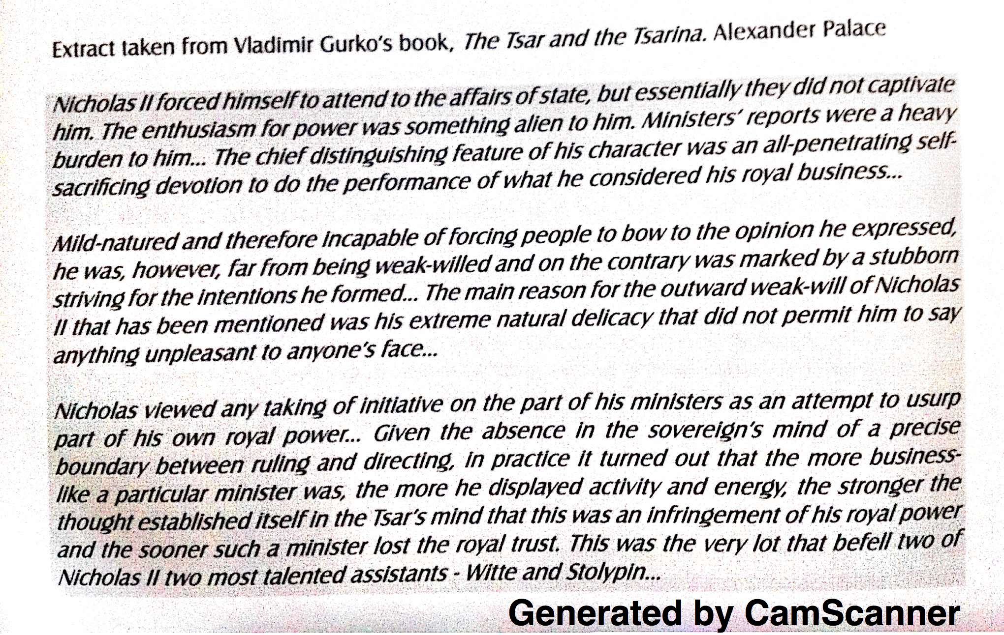

- Identify 2 statements that suggest that Nicholas did not enjoy his role of Tsar.

- Identify 2 characteristics or traits of the Tsar which Gurko states as flaws in the Tsars ability to rule.

- Using your knowledge and the extract above, explain how Nicholas’ personality and beliefs contributed to the growth of revolutionary ideas and movements.

- Explain the usefulness of this extract in understanding the role played by Nicholas in the downfall of the Romanov dynasty.

