Unit 3: The Russian Revolution
Area of study 1: Causes of the Revolution: 1896 to October 1917 - Timeline
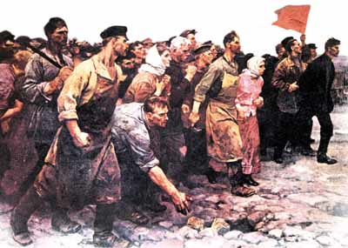

School Week | Topics | Outcome task/SAC | Reading
Term 1  Week  1 | Introduction outline assessment tasks, introduction to Russia, basic geography key cities, characteristics of population.  Brief outline of social structure, government structure, role of the Church and army. | Holiday Homework | Holiday Homework  p.19-25
2 | • The coronation of Tsar Nicholas II  • Sergei Witte’s Reforms  • The emergence of Revolutionary Groups |  | p.17-19  p.29-32  p36-47
3 | • Marxism  • Lenin (1870-1924)  • The emergence of the Bolsheviks  • Russo-Japanese War 8 February 1904 – 5 September 1905 | H.W Task 1 | p36-47  p51-57  p62-63
4 | • Bloody Sunday Massacre.- Sunday 9th of January 1905.  • The 1905 Revolution  • The Outcome of 1905- The October Manifesto |  | p.64-75
5 | • The Fundamental Laws of 1906  • The Duma  • Peter Stolypin and his reforms | H.W Task 2 | p. 81-91
6 | • Russia’s Involvement in WWI  • Nicholas’s key mistakes of the War:  • Social and Economic Discontent 1914-1917  • The February Revolution |  | p. 95-107  p. 121-134
7 | • Dual Government (February 1917- October 1917)  • The Provisional Government  • The Petrograd Soviet  • Failures of the Provisional Government | Practice Document Analysis Questions | p.137-145
8 | • Successes of the Bolsheviks  • Alexander Kerensky (1881-1970)  • Leon Trotsky (1879-1940)  • October Revolution  • Historical Perspectives on the Russian Revolution |  | p.145-p165
9 | Revision | SAC 1: Analysis of primary sources | p.110-115  p.168-175

Area of study 2: Consequences of the Revolution: November 1917 to 1927
Timeline

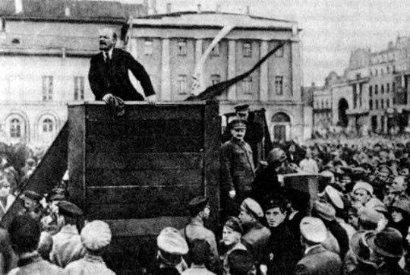
Image: Lenin (left) and Trotsky (right) addressing the people in Red Square 1920

School Week | Topics | Outcome task/SAC | Reading
Term 2 Week 1 | • Bolsheviks legitimize and consolidate their rule.  • Gaining official approval from the Petrograd Soviet  • Structuring and Strengthening Bolshevik Government  • Constituent Assembly  • Meeting the promise of “Peace, Bread and Land” | Holiday H.W | p.190-197
2 | • Social Reforms  • Russian Civil War (1918-1920)  • Why did the Bolsheviks win the Civil War?  • Why did the White Russian’s lose the Civil War?  • The murder of the Romanovs |  | p.198-200  p206-225
3 | • Introduction of War Communism (1918-1921)  • The effects of War Communism on Russian Society | Document Analysis Task | p.230-232
4 | • Kronstadt Revolt (26th Feb- 17th of March 1921):  • The New Economic Policy (March 1921) |  | p.233-242  p.246-255
5 | • The New Economic Policy - Cont  • Increased political repression  • Formation of the USSR (1922)  • Expansion of the Cheka | Practice essay questions | p.246-255  p.277
6 | • The Death of Lenin (1924)  • The end of the NEP (1927) |  | p.278-288
7 | Revision | SAC 2:  Historical inquiry | p.291-319

