Study Design Summary: Key Assessable Items
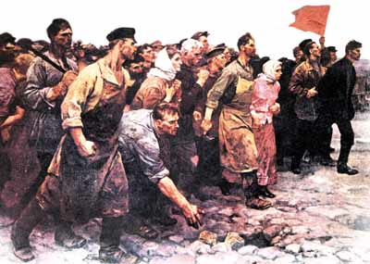
The following Movements, Ideas, Leaders (referred to as individuals in the VCE Study Design) and Events are all key knowledge items that come direct from the study design (page 64).

It is of course not a comprehensive list of all the content taught as part of Unit 3. However, it lists the key items, which you will be assessed on, in the November exam. Therefore, use this as a guide to facilitate your note taking in preparation for Outcome Tasks and Exam Revision.

Area of Study 1: Causes of Revolution (Key Questions)
- What were the significant causes of revolution?
- How did the actions of popular movements and particular individuals contribute to triggering a revolution? (Short-term triggers)
- To what extent did social tensions and ideological conflicts contribute to the outbreak of revolution? (Long-term effects)

Key skills

- Ask historical questions about the causes of revolution to inform an historical inquiry
- Analyse the long-term causes and short-term triggers of revolution
- Use primary sources as evidence to analyse the causes of a revolution
- Evaluate the significance of ideas, events, individuals and popular movements that contributed to the outbreak of the revolution
- Compare a range of historical perspectives to understand how the ideas and experiences of individuals and movements contributed to revolutionary causes
- Evaluate historical interpretations about the significant causes of a revolution
- Construct arguments about the causes of revolution using primary sources and historical interpretations as evidence.

Movements | Ideas | Leaders (Individuals) | Events
Peasant Movements | Nationalism Revolutionary Populism | Count Witte | Tensions in Tsarist Russia
Workers Movements Bolsheviks Mensheviks (SD's) | Marxism and Marxist-Leninism |  | Formation of the Bolsheviks and Mensheviks
 |  |  | Russo-Japanese War
Octobrists Kadets |  | Tsar Nicholas II | Bloody Sunday
 | Liberal Reformism | Pyotr Stolypin | The role of the Dumas
 |  | Tsarina Alexandra Grigori Rasputin | World War One
Soldier and Sailor Mutinies |  |  | The February Revolution
 |  |  | The effectiveness of the provisional government
Socialist Revolutionaries |  | Alexandra Kerensky | The Dual Authority
 |  | Lenin | Lenin's Return and April Theses
 |  |  | July Days
 |  |  | Kornilov Affair
 |  | Trotsky | Events of October 1917
Key knowledge:

